Customer life time value model
Outline
The project is to build a LTV model that can take look into transactional history and look for patterns/ relationships then form a estimate of time and number of transaction that this customer will make before they churn away.

Roadmap
- Initial exploration- learning and documenting the types of LTV models and the types of characteristics they are based on.
- Outline- write down the different sections of the model and an estimated time of how long itll take. – Due Friday 31/1
- Coding- Begin coding the different parts of the model- Due 21/2 February (MVP)
- Testing
- Publishing

- Exploration of CLV Models
Total profit of the entire relationship with a customer
- Cost to attract, service and maintain customer( cost to acquire)
- Customer transactions (MP x Revenue)
- Customer network effects (word of mouth)
Importance of CLV
- Customer segmentation to identify most profitable
- Identify traits and features of valuable customers
- Determine how to allocate resource among customers
- Enable evaluation of the cost to acquire
Contractual(subscription) vs Non Contractual Customer

Contractual
Customer ‘death’ can be observed
• Often modeled using
survival-based approaches

Non Contractual
• Customer ‘death’ is unobserved
• Customer lifetime distribution often
modeled via exponential models

Discrete vs Continuous purchases
Discrete purchases occur at fixed periods or frequencies
Continuous purchases can happen at any time

CLV = Total number of purchases for each customer vs Value of each transaction

Hierachical Baysian model
Individual customer parameters, mu
Constrained by and drawn from a population level distribution with parameters

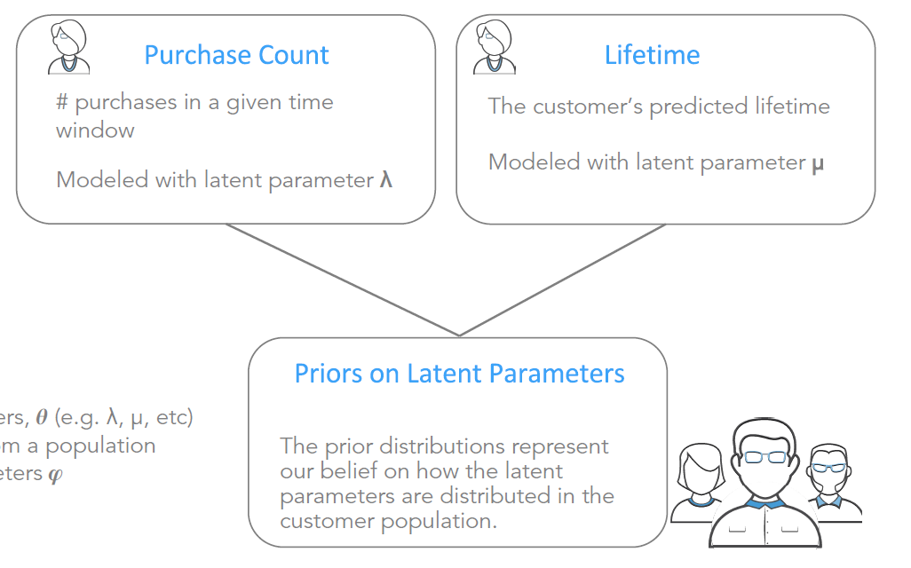

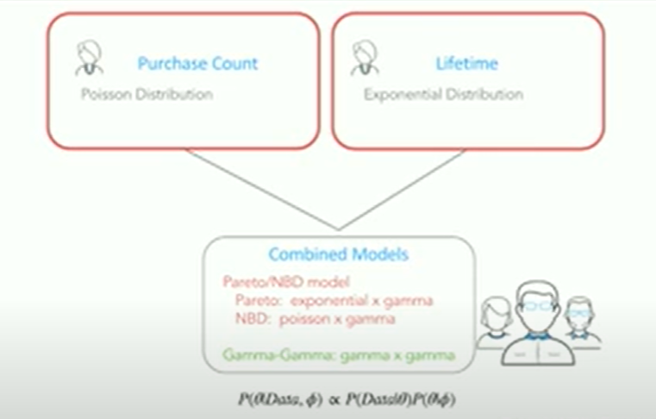

Poisson Distribution :
expresses the probability of a given number of events occurring in a fixed interval of time if these events occur with a known constant mean rate and independently of the time since the last event.

Models:

RFM models – Recency, frequency and monetary value
– Recency (Most recent purchase date)
– Frequency (Number of purchases)
– Monetary value (Total sales from customer)

